

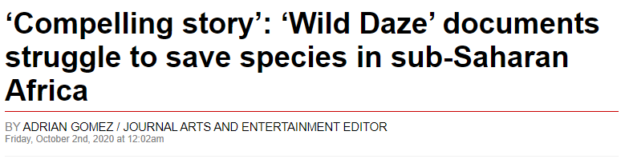

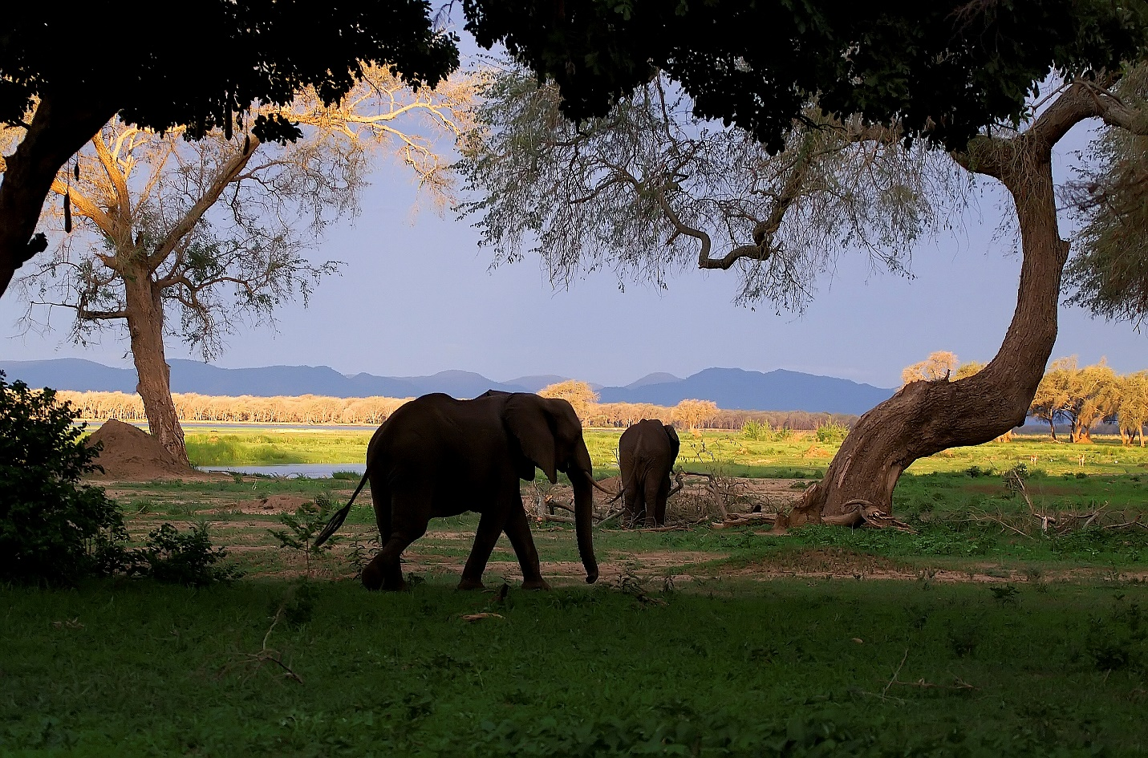

An elephant walking in Africa is pictured in the documentary “Wild Daze.” (Courtesy of Michael Poliza)

Phyllis Stuart was definitely on a journey while filming “Wild Daze.”

The documentary showcases and demonstrates the dire challenges facing species that depend on biodiversity.

Through interviews with conservation experts including Jane Goodall, Andrea Crosta, Will Travers and Azad “Oz” Ebrahimzadeh, along with trophy hunters and displaced indigenous African forest peoples, Stuart explores the relationships among international crime cartels, colluding government officials, animal poaching, the illegal ivory trade, cattle barons and human beings, as she examines how rampant corruption complicates the fight to save species nearing extinction.

“The hardest part is getting people to talk to me,” Stuart says. “I had people who could get kicked out of Kenya. Therefore, they have to watch what they say.”

“Wild Daze” is screening virtually in theaters across the nation. The Guild Cinema in Albuquerque and Jean Cocteau Cinema in Santa Fe are hosting screenings online.

Stuart traveled to sub-Saharan Africa to capture the ugly truth on the battle between humans’ paradoxical craving to control nature and our ultimate need to save the wild.

By sharing the beauty of Africa while revealing the dire and potentially irrevocable consequences caused by mankind, Stuart wants her film to opens the eyes of the viewers and warns them of what could happen if we do not do all we can to turn the tide against this ecocide.

Stuart wrote, produced and directed the film.

While editing the film, Stuart also tried to craft the most powerful story she could.

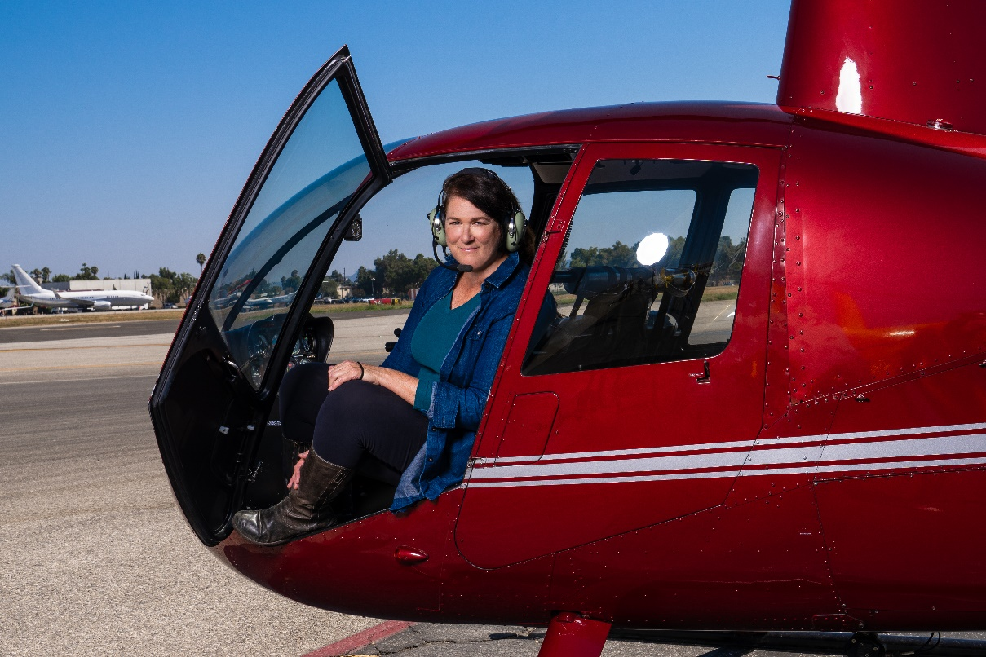

Filmmaker Phyllis Stuart spent months in Africa working on the documentary “Wild Daze.” (Courtesy of Moses Sparks)

“The most compelling story is about the journey to the film,” she says. “With every single interview, there was a hurdle to jump, but we got it done respectfully. … I hope that the film will help people understand what’s going on in Africa.”

As Stuart traveled for months at a time, she never felt unsafe.

“I hired a cameraman in Kenya, and I flew to Uganda,” she says. “What I often ran into was how, as Americans, we take freedom of speech for granted. All of these places I filmed, they couldn’t really tell the true story.”

Now that the film is out to for the world to see, Stuart feels a sense of relief.

“It’s really important now that we make changes to the way we have been doing things,” she says. “Many of the models to save animals simply don’t work. There has to be a better way to sustain the plans to keep them safe.”

“Wild Daze” is screening virtually at both the Guild Cinema – [guildcinema.com](http://guildcinema.com/) – in Albuquerque and the Jean Cocteau Cinema – [jeancocteaucinema.com](http://jeancocteaucinema.com/) – in Santa Fe.

<https://www.abqjournal.com/1502298/compelling-story.html>

# # #